You have made a lot of progress since the first milestone, and I would say that your website looks very nice overall. The one thing I would caution you about is that your website is very inefficient in disk space. It takes up over a gigabyte. With the point you are at, I think you may need to embed the videos from youtube or something, since that is what is taking the majority of the space. Having a big file size isn’t too big of an issue when not hosting a website, but could be a real pain if you had to actually host it. Not a big thing, don't take it that way, but just something to think about.

Here is a handy dandy chat:

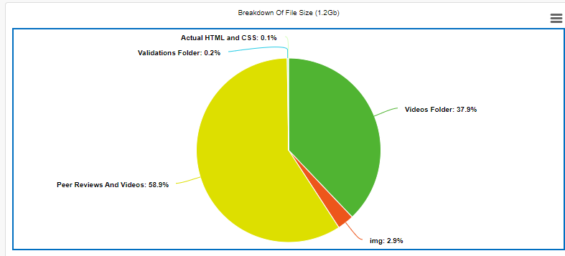

Now obviously you have to have validation, but you can cut down on nearly 40% of your size by embedding a youtube video.

I like that you have separate html documents for each review since it makes the site feel a lot more professional.

I think the color pallet still works really well. Maybe you could get rid of the underlining on your website header, and spruce it up. But that is very nitpicky, and it overall looks really good when it comes to contrast.

For your form you may want to try and make it more vertical since it may be harder for some people to actually read it. Just do that by adding a line break.

For consistency's sake you may want to put in a trailer for the video games and movies section, since you have the openings for the anime. That shouldn’t take too long, and that inconsistency isn’t too bad, so don’t take this too harshly.

The reviews themselves are well made, and seem to have had a lot of thought put into them so good job on that. Other than these things, which are a little nitpicky, admittedly, I think your site looks very good.